Multiple-choice section

|  |  |  |  |  |  |  |  |  |  |  |
| --- | --- | --- | --- | --- | --- | --- | --- | --- | --- | --- |
| Question | 1 | 2 | 3 | 4 | 5 | 6 | 7 | 8 | 9 | 10 |
| Answer | C | B | A | A | D | B | C | B | D | D |

Question 1 [9.1]

**C**

The highest power that appears in a quadratic expression is 2 (a squared term). **C** has a term raised to the power of 3.

Question 2 [9.3]

**B**

*y* = (*x +* 4)2 – 1

+4 indicates a translation of 4 units to the left – 1 indicates a translation 1 unit down.

Question 3 [9.3]

**A**

The dilation factor is the coefficient of the term of the second degree. It is represented by *a* in *ax*2 + *bx* + *c*. The coefficient is -2, so the dilation factor is -2.

Question 4 [9.4]

**A**

The equation of a circle is *x*2 + *y*2 = *r*2. The equation that graphs as a circle is *x*2 + *y*2 = 16.

Question 5 [9.2]

**D**

*x*2 + 5*x* – 24 = 0

(*x* + 8)(*x* – 3) = 0

(*x* + 8) = 0

*x* = -8

(*x* – 3) = 0

*x* = 3

*x* = -8 or 3

Question 6 [9.6]

**B**

 so *k* = 7

Substitute *k* into *y* = *kx*.

*y* = 7*x*

Check against a value in the table.

When *x* = 2

*y* = 7 × 2

*y* = 14

Question 7 [9.4]

**C**

The graph of a circle is represented by the equation *x*2 + *y*2 = *r*2.

The translated graph (*x –* 1)2 + (*y* + 2)2 = 144 has centre at (*h*, *k*), where *h* = 1, *k* = -2.

 The centre is at (1, -2).

The *r*2 term gives the radius.

 so the radius is 12.

Question 8 [9.3]

**B**

When *y* = 0,

0 = (*x* + 5)(*x* – 7)

*x*-intercepts are -5 and 7.

Halfway between the *x*-intercepts, *x* = 1.

Where *x* = 1,

*y* = 6 × -6

= -36

Turning point is (1, -36).

Question 9 [9.5]

**D**

Substituting the values of *h =* -4 and *k =* 3 (the asymptotes of the graph) into the general equation *y* = + *k* yields the equation *y* = + 3.

Question 10 [9.7]

**D**

*p* **   *p* = 

If k = 45  p = 

Multiple-choice total marks: 10

Short answer section

Question 11 4 marks [9.1]

**(a)** Use *x* = , *y* = -*x*2 – 3*x* – 4: *a* = -1, *b* = -3

*x* =  =  = 

Where *x* = :

*y* = -()2 + (-3 × ) – 4

*y* =  + 4 – 4

*y* = 

Turning point is (, ).

**(b)** From the graph, there are no *x*-intercepts.

**(c)** To find the *y-*intercept, let *x* be 0.

*y* = -*x*2 – 3*x* – 4

*y* = 02 – 0 × 3 – 4

*y* = -4

*y*-intercept at (0, -4)

Or

From the graph, the *y*-intercept is at (0, -4).

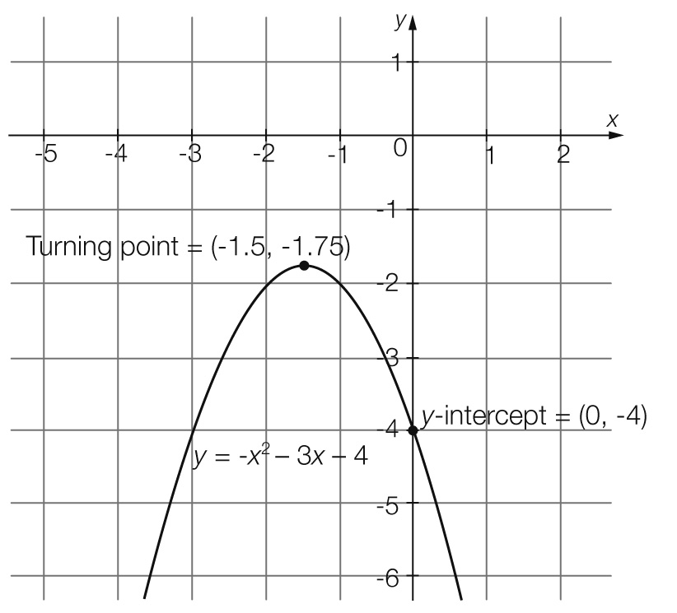

**(d)** The axis of symmetry is the *x*-value of the turning point, which is at *x* = -1.5.

Question 12 9 marks [9.1]

**(a)** *y* = 2*x*2 – 5*x* – 7

|  |  |  |  |  |  |  |  |  |
| --- | --- | --- | --- | --- | --- | --- | --- | --- |
| *x* | -2 | -1 | 0 | 1 | 2 | 3 | 4 | 5 |
| *y* | 11 | 0 | -7 | -10 | -9 | -4 | 5 | 18 |

**(b)**

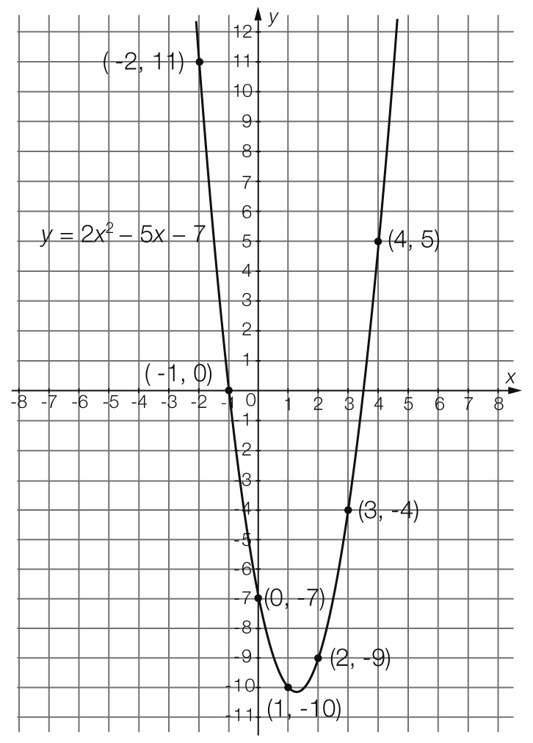

**(c)** The graph does not show the turning point, so add the *x*-intercept values and divide by 2:

-1 + 3.5 = 2.5

2.52 = 1.25

* x* = 1.25

Where *x* = 1.25

*y* = 2 × 1.252 – 5 ×  – 7

*y* = 2 × 1.5625 – 6.25 – 7

*y* = -10.125

Turning point is (1.25, -10.125).

**(d)** The graph has a minimum turning point.

**(e)** Substitute *x* = 8 into *y* = 2*x*2 – 5*x* – 7:

*y* = 2 82 – 58 – 7

 *y* = 81

Question 13 6 marks [9.2]

|  |  |  |
| --- | --- | --- |
| **(a)** *x*2 – 11*x* + 24 = 0  (*x* – 3)(*x* – 8) = 0  *x* – 3 = 0  *x* – 3 + 3 = 0 + 3  *x* = 3  *x* – 8 = 0  *x* – 8 + 8 = 0 + 8  *x* = 8  *x* = 3 or 8 | **(b)** *x*2 + 3*x* = 28  *x*2 + 3*x* – 28 = 0  (*x* – 4)(*x* + 7)= 0  (*x* – 4) = 0  *x* – 4 + 4 = 0 + 4  *x* = 4  *x* + 7 = 0  *x* + 7 – 7 = 0 – 7  *x* = -7  *x* = -7 or 4 | **(c)** 2*x*2 – 12 = 0  2(*x*2 – 6) = 0  2(*x*2 – () 2) = 0  2(*x* –)(*x* + ) = 0  *x* –= 0 or *x* +  = 0  *x* = or *x* = - |

Question 14 2 marks [9.2]

*y* = 2*x*2 + 6*x* + 4

0 = 2*x*2 + 6*x* + 4

0 = 2(*x*2 + 3*x* + 2)

0 = 2(*x* + 1) (*x* + 2)

*x* + 1 = 0 or *x* + 2 = 0

*x* = -1 or *x* = -2

*x*-intercepts at (-1, 0) and (-2, 0)

Question 15 6 marks [9.3]

|  |  |  |  |  |  |
| --- | --- | --- | --- | --- | --- |
|  | **Equation** | **Dilation**  **factor** | **Reflection in *x-*axis** | **Translation in *x*-direction** | **Translation in *y*-direction** |
| **(a)** | *y* =  *x*2 + 1 | *a* = | No reflection | No translation | Translated  1 unit up |
| **(b)** | *y* = 4(*x* – 4)2 – 1 | *a* = 4 | No reflection | Translated  4 units to the right | Translated  1 unit down |
| **(c)** | *y* = -3(*x* + 2)2 – 1 | *a* = -3 | Reflected in the *x*-axis (upside down) | Translated 2 units to the left | Translated 1 unit down |

Question 16 6 marks [9.4]

**(a)** *x* min = -7, *x* max = 1, *y* min = -2, *y* max = 6

*x* =  =  = -3

*y* =  =  = 2

centre: (-3, 2)

*r* =  =  = 4

*h* = -3, *k* = 2, *r* = 4

**(b)** centre: (-3, 2), *r* = 4

(*x – h*)2 + (*y – k*)2 = *r*2

(*x* – (-3))2 + (*y* – 2)2 = 42

equation of the circle is: (*x* + 3)2 + (*y* – 2)2 = 16

Question 17 2 marks [9.4]

**(a)** (*x* + 5)2 + (*y* + 3)2 = 36

original circle *h* = 5, *k* = 3, *r* = 6

transformed circle *h* = -6, *k* = -4, *r* = 7

(*x – h*)2 + (*y – k*)2 = *r*2

(*x* – 1)2 + (*y* – 1)2 = 49

**(b)** (*x* – 1)2 + (*y* + 1)2 = 49

Question 18 4 marks [9.5]

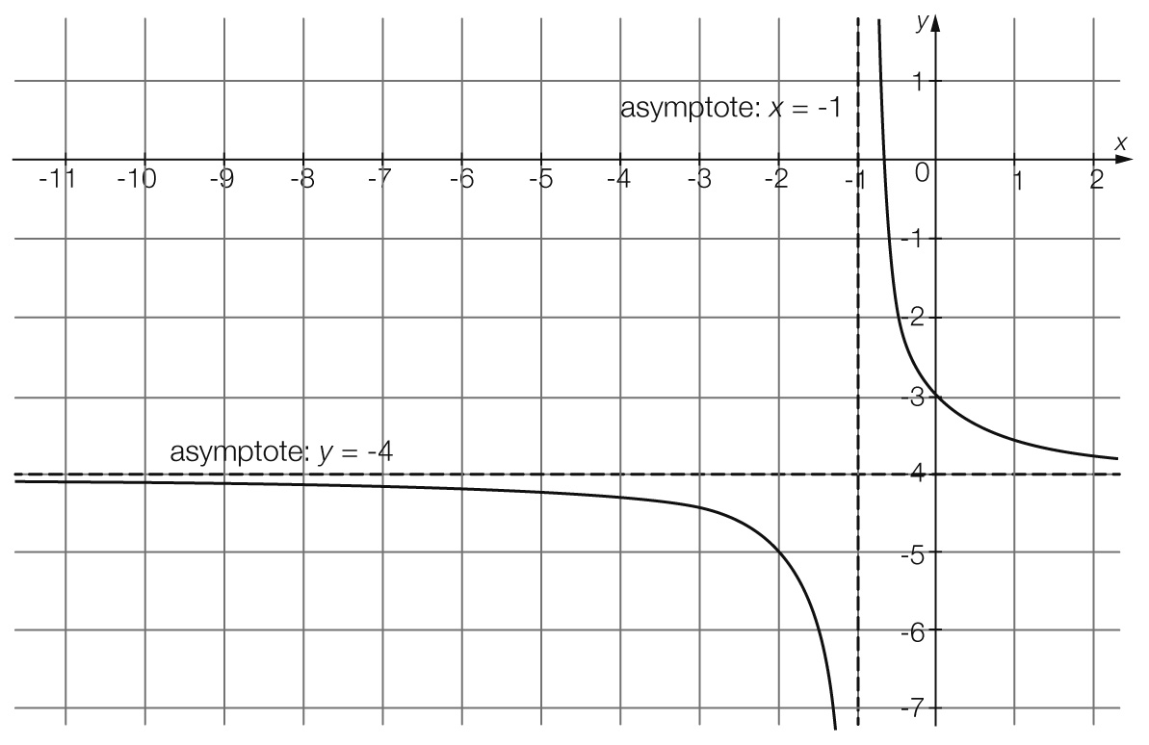

**(a)** rectangular hyperbola

**(b)** Horizontal asymptote is at *y* = -4.

**(c)** Vertical asymptote is at *x* = -1.

**(d)** The general form of a rectangular hyperbola is.

*a* = 1, *h* = -1 and *k* = -4

The equation is: 

Question 19 4 marks [9.6]

**(a)** Use the direct proportion general form:   
*y = kx*

*P = s*3*k*

**(b)** 3.8 = 19.33*k*

3.8 = 7189.057*k*

*k* = 0.000 528 6 (4 dp)

**(c)** When *s =* 24.2 and *k* = 0.0005

*P* = 24.23 × 0.0005286

*P* = 7.49 MW

**(d)** When *P* = 2.45

2.45 = *s*3 × 0.0005286

*s*3 = 4900

*S* = 16.67 km/h

Question 20 4 marks [9.7]

**(a)** As *x* is increasing, *y* is decreasing. This relationship could be inversely proportional.

**(b)** *x* *y* = *k*

236 = 72

418 = 72

6 12 = 72

8  9 = 72

Therefore, *k* = 72

**(c)**  , *k* = 72

 or *xy* = 72

**(d)** Where *x* = 24

*y* = 

*y* = 3

Short answer total marks: 44

*Extended answer section*

Question 21 9 marks [9.1]

**(a)** *h* = -5*t*2 + 15*t*

|  |  |  |  |  |
| --- | --- | --- | --- | --- |
| *t* | 0 | 1 | 2 | 3 |
| *h* | 0 | 10 | 10 | 0 |

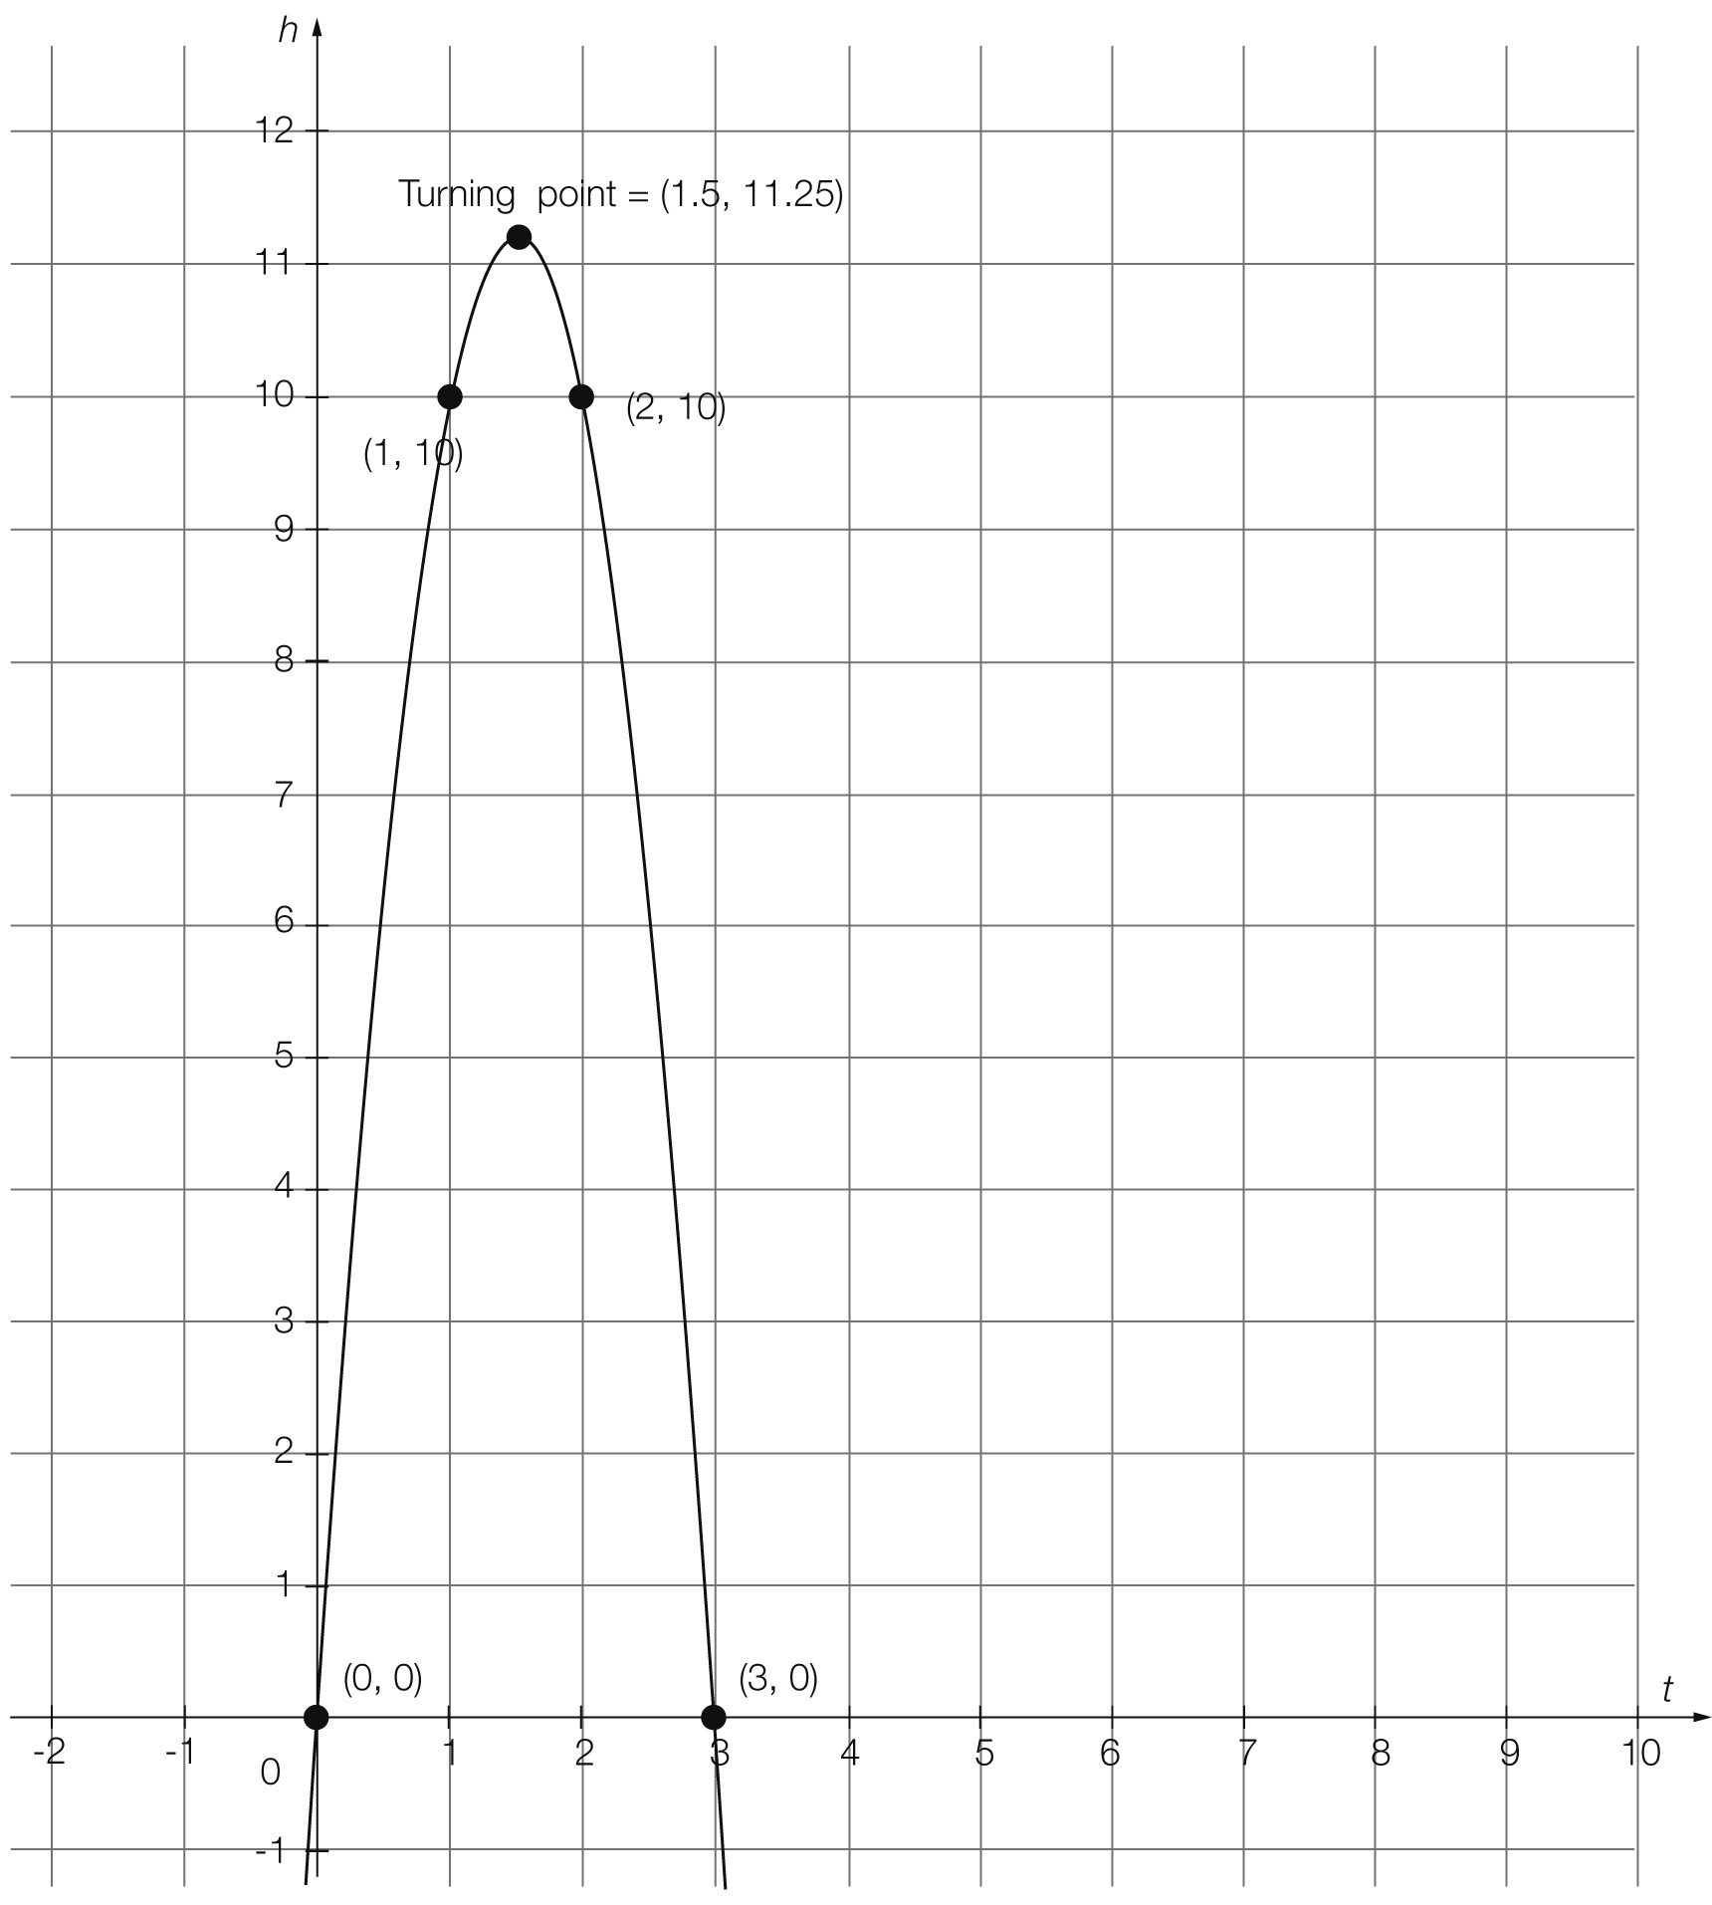

**(b)** From the graph, the maximum height of the ball is 11.25 m.

**(c)** The ball reaches its maximum height at 1.5 seconds.

**(d)** From the graph, the ball hits the ground at 3 seconds.

Question 22 4 marks [9.1]

**(a)** *h* = 4, *k* = 0 and *r* = 3

(*x – h*)2 + (*y – k*)2 = *r*2

(*x –* 4)2 + (*y –* 0)2 = 32

equation: (*x –* 4)2 + *y*2 = 9

**(b)**given the centre of the circle (4, 0) and radius 3

*x* min = 4 – 3 = 1, *x* max = 4 + 3 = 7, *y* min = 0 – 3 = -3, *y* max = 0 + 3 = 3

coordinates: (1, 0) (7, 0) (4, -3) (4, 3)

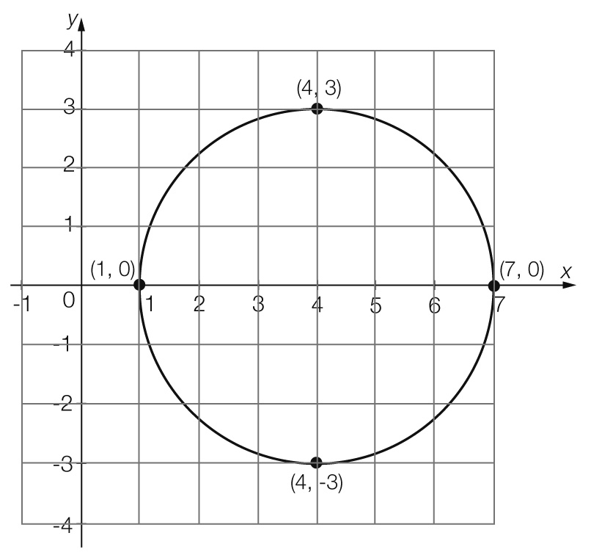

Question 23 5 marks [9.7]

**(a)** The volume is increasing whilst the pressure decreases; this could be inverse proportion.





*k* = 5000



*k* = 5000

When the volume is 2 L the pressure is:



*P* = 2500 kPa

When the volume is 4 L the pressure is:



*P* = 1250 kPa

|  |  |  |  |  |
| --- | --- | --- | --- | --- |
| Volume (*V*) | 2 | 4 | 8 | 10 |
| Pressure (*P*) | **2500** | **1250** | 625 | 500 |

(b)

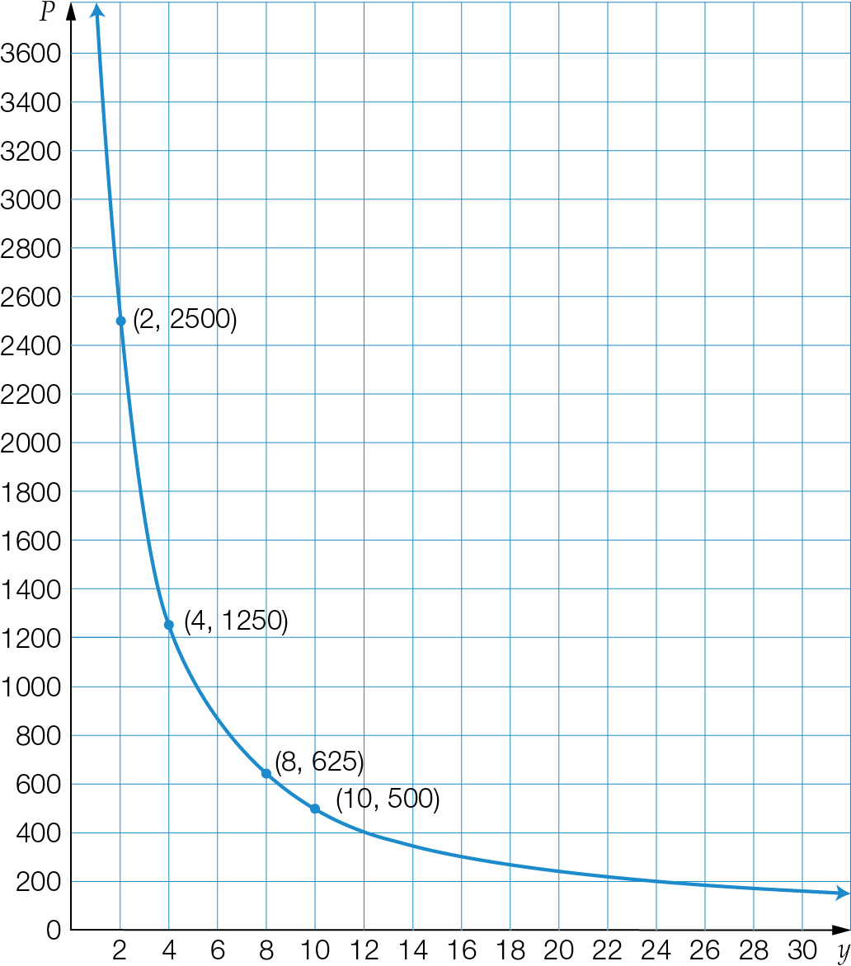

**(c)** The relationship is an example of inverse proportion as the graph is hyperbolic and has the equation . Also, as the volume is increasing, the pressure is decreasing.

**(d)** 

1800*V* = 5000

*V* = 2.78 L

Question 24 7 marks [9.5]

**(a)** *y* = 2(*x* – 4) + 1

|  |  |  |  |  |  |  |  |  |
| --- | --- | --- | --- | --- | --- | --- | --- | --- |
| *x* | 0 | 1 | 2 | 3 | 4 | 5 | 6 | 7 |
| *y* | 1.0625 | 1.125 | 1.25 | 1.5 | 2 | 3 | 5 | 9 |

**(b)**

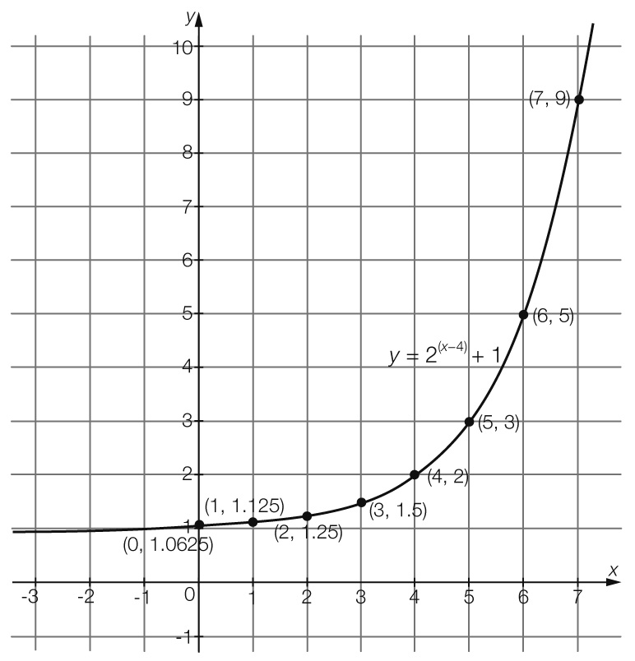

**(c)** exponential relationship

**(d)** Asymptote is at *y* = 1.

**(e)** Where *x* = 12,

*y* = 2(*x* – 4) + 1

*y* = 2(12– 4) + 1

*y* = 28 + 1  *y* = 257

Extended answer total marks: 25

TOTAL test marks: 79